**READ ME**

Q1.2.1 , Q1.2.2, Q1.3 using Python version 2.7.14

**1.2.1**

Assignment 1.2.1.py :

Python file containing the code for capturing game statistics for 10000 runs of the tic tac toe game and probabilistically calculating the auspiciousness of each cell of the game board.

Outputs:

1. *Probability Matrix* (each cell position and corresponding probability)
2. *Game Stats.xlsx* (excel file containing the data for each winning game- Winning player, game board, winning 3-in-a-row configuration)
3. *Histogram (Players move randomly).png* (histogram displaying the frequency count of wins by player 1, wins by player 2 and draws)

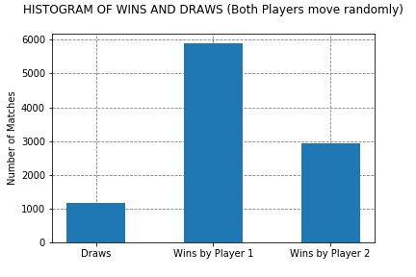

**1.2.2**

Assignment 1.2.2.py :

Python file containing the code for reading the probability matrix from Game Stats.xlsx and using the cell probabilities for Player X’s moves. Histogram plotted for 10000 matches.

Outputs:

1. *Histogram (Players X probabilistic, Player O random).png* (histogram displaying the frequency count of wins by player 1, wins by player 2 and draws)

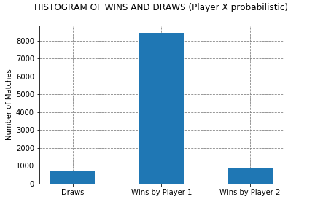

**1.3**

Assignment 1.3.py :

Python file containing the code for Player X playing with heuristic moves and Player O making random moves. Histogram plotted for 10000 matches. The following heuristic was used:

1. 3 cells in a line empty : +1
2. One of player’s symbol in a line : +10
3. One of opponent’s symbol in a line: -10
4. Both player’s and opponent’s symbol in a line: 0
5. Two of player’s symbols in a line: +150
6. Two of opponent’s symbols in a line: +100

Outputs:

1. *Histogram (Players X heuristic, Player O random).png* (histogram displaying the frequency count of wins by player 1, wins by player 2 and draws)

